1. 用非平衡电桥测量铜电阻温度系数

0℃时电阻的阻值近似认为，电源电动势

|  |  |  |  |  |  |  |  |  |
| --- | --- | --- | --- | --- | --- | --- | --- | --- |
|  | 18.8 | 27.2 | 35.0 | 40.0 | 47.9 | 55.9 | 60.3 | 66.2 |
|  | 30.6 | 41.1 | 50.7 | 56.3 | 65.4 | 74.5 | 79.1 | 85.7 |
|  | 0.00526 | 0.00496 | 0.00483 | 0.00474 | 0.00467 | 0.00463 | 0.00460 | 0.00460 |

，理论值为

相对误差

1. 描绘铜电阻温度特性曲线

由于实验中，可知

|  |  |  |  |  |  |  |  |  |
| --- | --- | --- | --- | --- | --- | --- | --- | --- |
|  | 27.1 | 35.3 | 40.0 | 48.0 | 55.9 | 59.8 | 67.1 | 69.9 |
|  | 57.27 | 59.05 | 60.03 | 61.78 | 63.46 | 64.34 | 65.94 | 66.51 |

经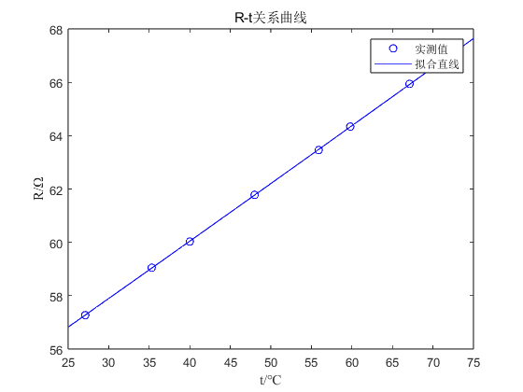MATLAB拟合直线



可知

相对误差